Profile Management Design Requirements

Table of Contents

Profile Management Design Requirements 1

1. Overview 3

1.1 Load Profile 3

1.2 Save Profile 3

1.3 Manage Profiles 3

2. Favourite Profiles 4

2.1 Existing OK5 functionality 5

2.2 Additional Features Required 5

3. Profiles Additional Options / Custom Actions 6

3.1 Existing OK5 Functionality 6

3.2 Additional Features Required 8

4. Save Dialog 8

4.1 Existing OK5 functionality 9

4.2 New Features Required 9

5. Profile Manager Feature 9

5.1 Existing OK5 functionality 11

5.2 New Features Required 13

6. Global Profile Manager 14

6.1 Existing OK5 Functionality 14

6.2 Additional Features Required 15

1. Overview

The following are the three basic flows required:

* 1. Load Profile

1. Open a screen
2. Access your frequently used profiles
3. Select a profile to load
   1. Save Profile
4. Open a screen
5. Make changes to query builder or Properties panel
6. (Optionally) Design screen
7. Save profile
   1. Manage Profiles
8. Access a screen
9. Open the Profile Manager
10. Manage favourites
11. Delete Profiles
12. Export / Import Profiles
13. Favourite Profiles

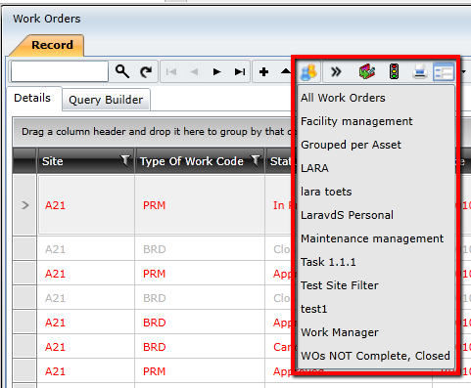

* 1. Existing OK5 functionality

|  |  |  |
| --- | --- | --- |
| Use Case | Purpose | Priority |
| Favourites / Frequently Used Profiles | A subset of “Favourites” or frequently used profiles is helpful to the user to quickly switch between screens to save time. | High |
| Indicator at bottom of screen of which profile you are currently using |  | High |

* 1. Additional Features Required

|  |  |  |
| --- | --- | --- |
| Use Case | Purpose | Priority |
|  |  |  |

1. Profiles Additional Options / Custom Actions

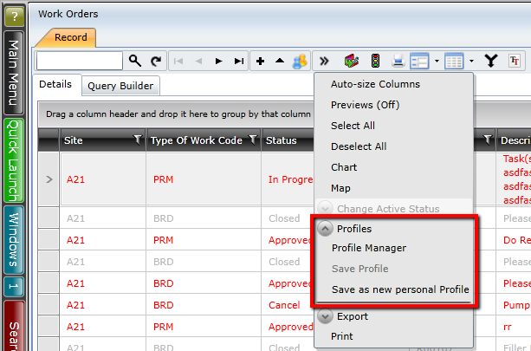

* 1. Existing OK5 Functionality

|  |  |  |
| --- | --- | --- |
| Use Case | Purpose | Priority |
| Open Profile Manager | The user will need to be able to access the Profile Manager. Profile Manager contains a log of custom actions which will | High |
| Save changes to an Existing Profile | Users make changes to their screen which can be via the Query Builder, Properties Panel or Designer and would like to save it to refer to it at a later stage. Without having to do the configuration again. | High |
| Save as a New Profile | Quite often, a user unintentionally makes a change to the query of an existing profile, or the visual properties of the screen, and would not want it to override the existing profile.  The user then has the option to save it rather as a new profile. | High |

* 1. Additional Features Required

|  |  |  |
| --- | --- | --- |
| Use Case | Purpose | Priority |
|  |  |  |

1. Save Dialog

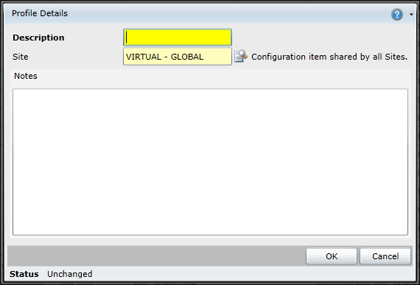

* 1. Existing OK5 functionality

|  |  |  |
| --- | --- | --- |
| Use Case | Purpose | Priority |
| Save a profile |  | High |
| Provide Name |  | High |
| Provide Description |  | High |
| Provide Notes? |  | High |
| Specify the Site the profile will be used for |  | Out of scope |

* 1. New Features Required

|  |  |  |
| --- | --- | --- |
| Use Case | Purpose | Priority |
| Specify if the Profile you have created is a Public or a Private Profile | Enum to say either Public or Private | High |
| Specify the operational role that the profile will be associated with |  | Low |

1. Profile Manager Feature

This relates to the Profile Manager screen that users use to manage profiles related to the resource that the user is on.

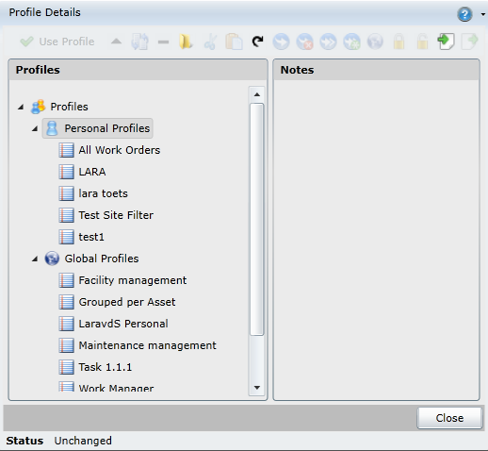

* 1. Existing OK5 functionality

|  |  |  |  |
| --- | --- | --- | --- |
| Use Case | Purpose | Priority | When is it available |
| Select and load a profile from Profile Manager |  | High | Only when profile is selected |
| Edit a profile | This allows the user to change the name of the profile or the description. | High | Only when profile is selected |
| Clone a profile | Duplicate a profile in profile manager. User is then prompted to provide a different name and can edit the description.  When a user clones a profile, they need to provide a new name & description | High | Only when profile is selected |
| Provide a Name of a Profile | Name provides a means to identify a specific profile | High | Only when editing a profile |
| Provide a Description for a Profile | Profiles can potentially have similar names, the description of the profile allows the user to understand the purpose of the profile, such as the visualisation, the filter criteria, etc. | High | Only when editing a profile |
| Differentiate between Private and Public profiles | Replaces Personal and Global Profiles | High | Only when editing a profile |
| Group lists of Profiles using folders | Clients will typically have long lists of Profiles for each resource.  Large organisations will require large number of profiles.  Being able to group profiles in folders allow the users to manage the profiles easier. | High | Only when folder or parent folder / group is selected |
| Export a profile | Export the profile on a resource (typically something that has a lot of configuration) and import it into a different On Key, to save configuration time.  Opens location on your desktop where you want to store the file. | High | When profile or a folder is selected. |
| Import an existing profile | Import the profile on a resource (typically something that has a lot of configuration) and import it into a different On Key, to save configuration time.  Opens location on your desktop where you want to lookup the file you would like to import. | High | When profile or a folder is selected. |
| Delete Profile or folder | When a profile is not longer users want to remove the profile completely | High | When profile or a folder is selected. |
| Change Active | Sometimes users don’t want to lose profiles, however they temporarily would like to remove it from being visible, therefore they want to change it to inactive. | High | When profile or a folder is selected. |
| Global Default | Note: Will this still be a thing? Don’t think so. | Out of Scope for now |  |
| Set initial profile | Note: will we first see whether Operational Roles can cater for the Initial Profiles Feature | Out of Scope for now |  |
| Lock Profile |  | Out of scope |  |
| Unlock Profile |  | Out of scope |  |

* 1. New Features Required

|  |  |  |
| --- | --- | --- |
| Use Case | Purpose | Priority |
| Manage the users preferred default within an Operational Role? | Users will be able to change their default profile, IF they have sufficient user rights and another profile is available. | High |
| Group lists of Profiles based on Operational Role | User’s functions will be grouped by Operational Role, and therefore it will be important to indicate this in the UI.  Each operational role that the user has will have a different default profile for each resource. | High |
| Create New Profiles from Scratch | If a user is creating a profile that deviates considerably from the system default, it may be less effort to just start from a blank page.  Note: Not sure if this will just be a custom action that takes you to the Designer Page? | Medium |
| Ability to assign profiles to an operational role from the Profile Manager | Whilst creating new profiles and working in the space of a certain resource, the user will want to be able to in that space assign profiles to a certain operational role. | Medium |
| Be able to specify which profiles are visible in the short list (i.e. Favourites / Frequently Used) | For companies with long lists of profiles, there are a couple of profiles that will be more frequently used than others.  On Key 5 merely had a list with the first number of profiles that were inserted. | Medium |
| Open a profile in the designer | There will be some configuration that the user will not be able to do from the properties panel and the user will have to have a mechanism to quickly navigate to the designer, make the configurational changes, and save them. | New |
| Indication that a profile has changed from what is saved, and that the users needs to save changes again. | UI aid to assist users and prevent losing unsaved changes. | New |

1. Global Profile Manager
   1. Existing OK5 Functionality

This feature was not available in On Key 5.

* 1. Additional Features Required

|  |  |  |
| --- | --- | --- |
| Use Case | Purpose | Priority |
| Ability to view a list of all profiles existing in On Key. | This Global Profile Manager screen will be important when users configure Operational Roles.  Users will have to assign Profiles to an Operational Role (or vice versa)  (Basically, just a dashboard of all profiles is what we specifically need) | High |
| Custom action to link to Profiles to Operational Roles |  | Medium |
| Launch Screen in new tab |  |  |